**Code Alpha Project**

**Task:- 1**

**Task Name :- Basic Network Sniffer**

**Name :- Mayur Singhania**

**Using a Python library such as Scapy to record and examine network traffic is the first step in creating a network sniffer. Scapy is suited for network analysis since it lets you work with packets at a low level.**

**To build it we have to follow some steps:-**

1. **1. Install Python 3 in order to run the script, since Python will be used to create the network sniffer.**

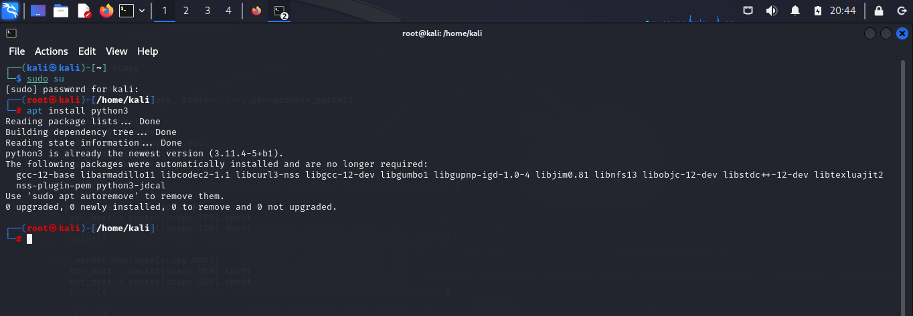**Command :- apt install python3**

1. **We also need to install Scapa in order to run the script and ensure its successful operation. Additionally, keep in mind that we are unable to install Scapy as the root user due to the possibility of system file corruption.**

**Command :- pip install scapy**

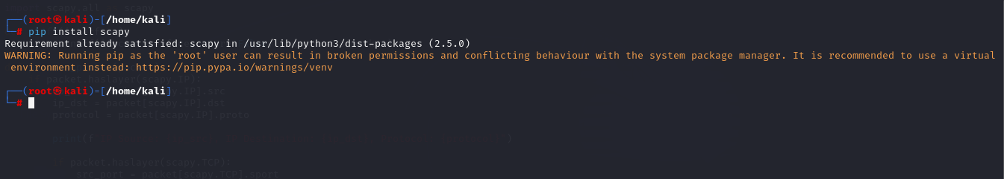

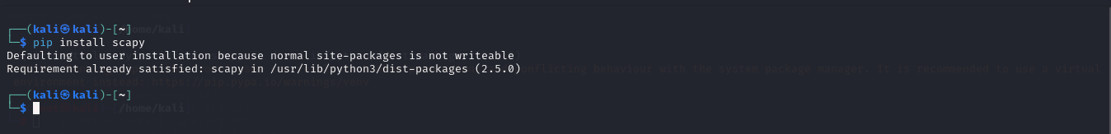

1. **3. The next and last step is to write a Python script to construct a network sniffer.**

**Command :- vi sniffer.py or vim sniffer.py**

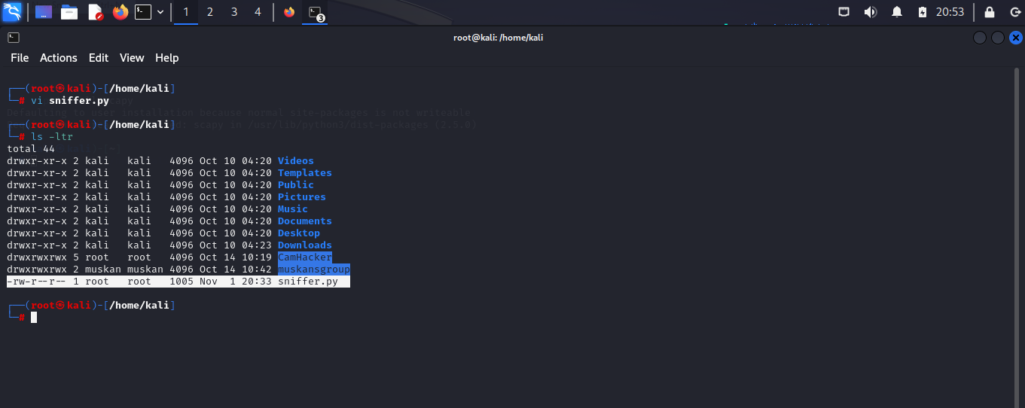

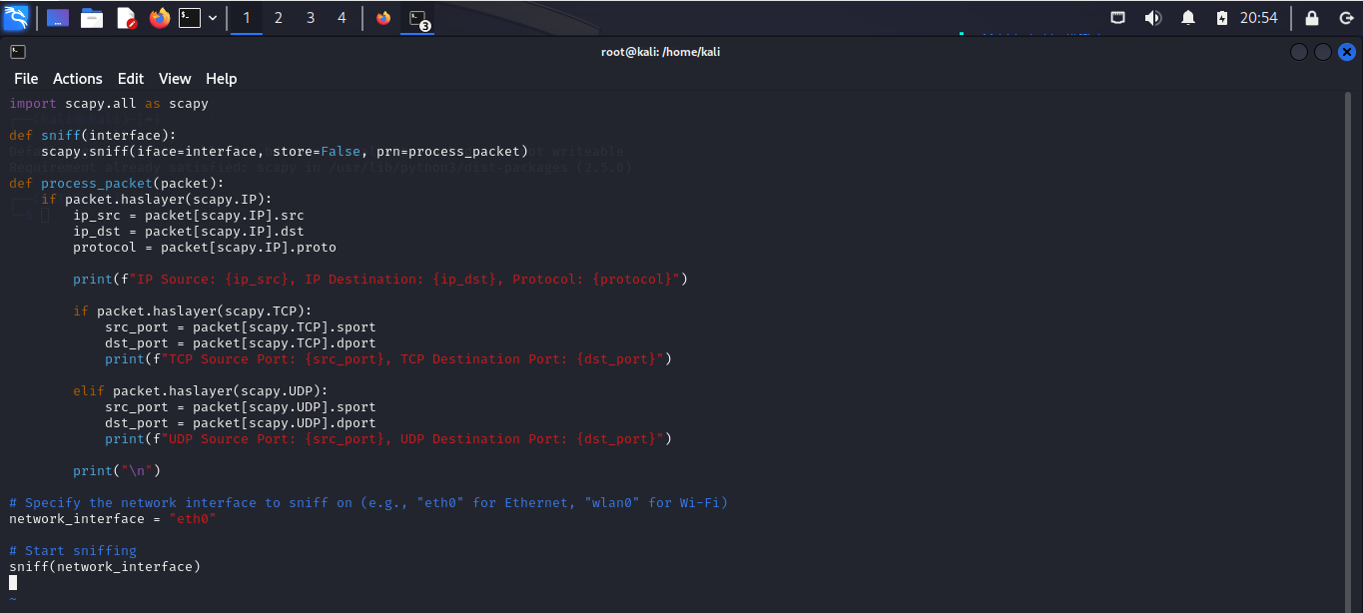

**The script can now be executed with the command python3 sniffer.py .**

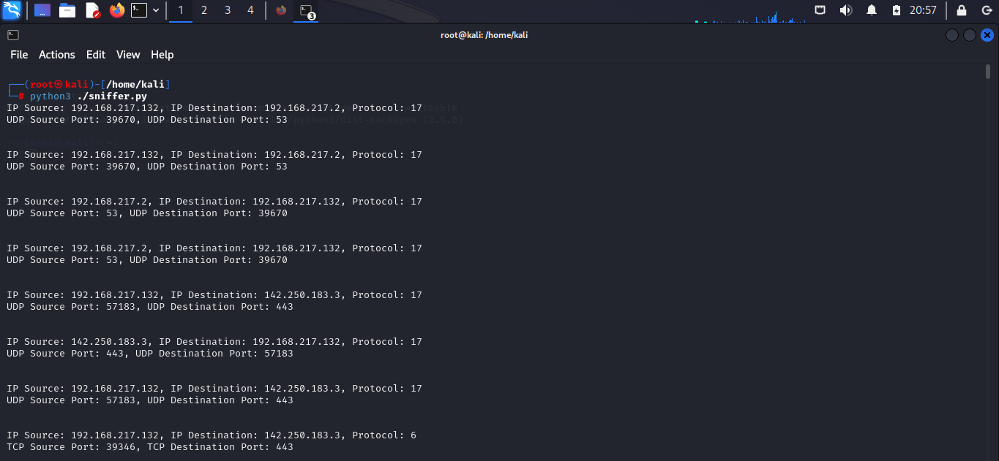**Final Result :-**

**Code Explanation :-**

* **The sniff function captures packets on the specified network interface (iface). The store=False parameter prevents Scapy from storing packets in memory (useful for long-term captures), and prn is set to the process_packet function, which is called for each captured packet.**
* **The process_packet function extracts information from the packet, such as source and destination IP addresses and protocol. If the packet is a TCP or UDP packet, it extracts source and destination port information.**